GROUP NAME: THE BYTE BANDITS

PROJECT TITLE: UNIT CONVERTER

GROUP MEMBERS NAME NAMES AND MATRIC NUMBER

OBINNA BROWN SOKO BHU22/04/05/0035

Mebusaiye Victor Timilehin BHU/22/04/09/0030

Nnamdi Divine Tochukwu BHU/22/04/09/0020

Edward Samson Kanbai BHU/22/04/10/0007

Chukwuji Peace Divine BHU/22/04/09/0100



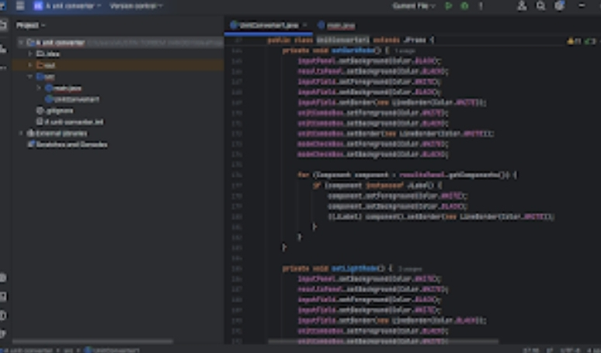

**Obinna Brown Soko BHU/22/04/05/0035**

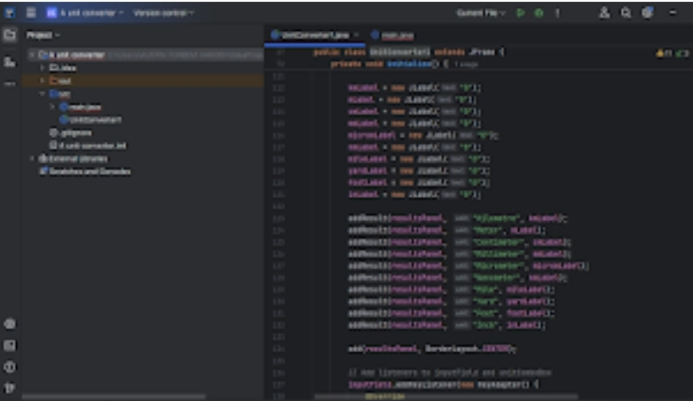

**Obinna Brown Soko BHU/22/04/05/0035**

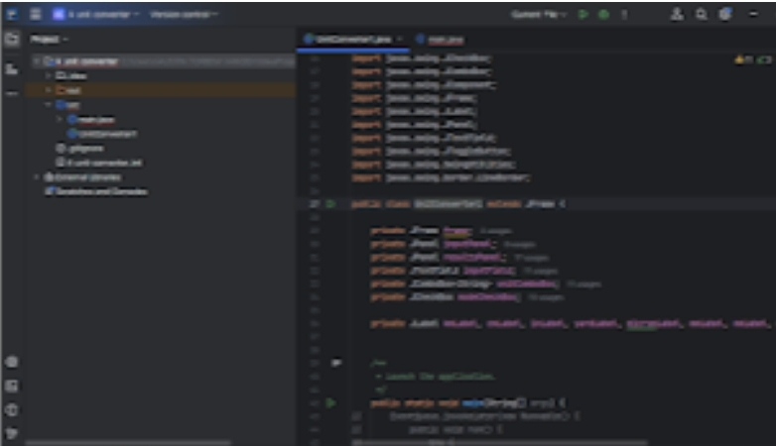

**Obinna Brown Soko BHU/22/04/05/0035**

